**DAILY ONLINE ACTIVITIES SUMMARY**

|  |  |  |  |  |  |  |  |  |
| --- | --- | --- | --- | --- | --- | --- | --- | --- |
| **Date:** | **26/06/2020** | | | | | **Name:** | **Katira Krishna J** | |
| **Sem & Sec** | **8th A** | | | | | **USN:** | **4AL16CS045** | |
| **Online Test Summary** | | | | | | | | |
| **Subject** | | **-** | | | | | | |
| **Max. Marks** | | **-** | | **Score** | | | **-** | |
| **Certification Course Summary** | | | | | | | | |
| **Course** | **Deep Learning with TensorFlow** | | | | | | | |
| **Certificate Provider** | | | **Cognitiveclass.ai** | | **Duration** | | | **10 hours** |
| **Coding Challenges** | | | | | | | | |
| **Problem Statement: Python program to find all numbers which are odd and palindromes between a range of numbers without using recursion** | | | | | | | | |
| **Status: Completed** | | | | | | | | |
| **Uploaded the report in Github** | | | | | **Yes** | | | |
| **If yes Repository name** | | | | | **Krishna_Katira** | | | |
| **Uploaded the report in slack** | | | | | **Yes** | | | |

Online Test Details:

No test Conducted

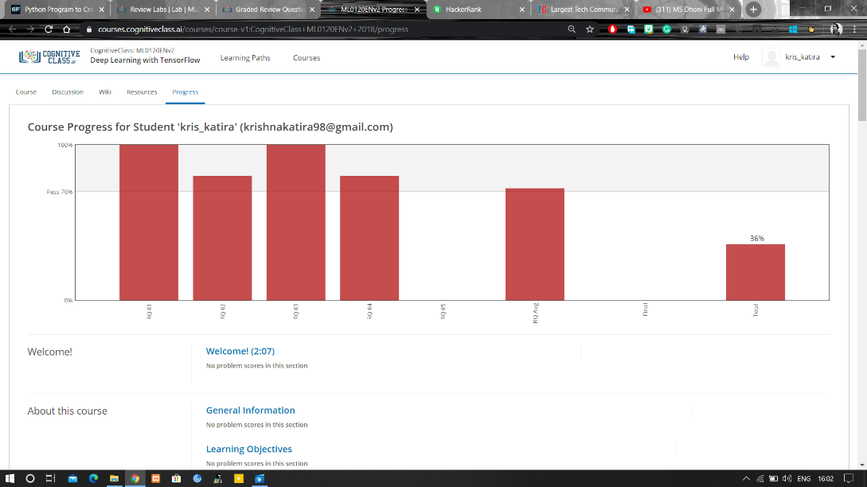Certification Course Details:

Coding Challenges Details:

**Program:**

a=[]

l=int(input("Enter lower limit: "))

u=int(input("Enter upper limit: "))

a=[x for x in range(l,u+1) if x%2!=0 and str(x)==str(x)[::-1]]

print("The numbers are: ",a)